**1. Introduction**

**1.1 Institute Profile**

Institute of Management and Career Courses (IMCC) is a premier Management Institute, established in 1983 by Maharashtra Education Society (MES) for providing quality education and technical expertise at the Post Graduation Level in the Fields of Computers and Management. The Institute is recognized by SPPU under Section 46 of Pune University Act, 1974 and Section 85 of Maharashtra University Act, 1994 and Approved by AICTE New Delhi to conduct MCA and MBA programmes. The Institute is located at 131, Mayur Colony, Kothrud, Pune-411038 having 30,000 sq. ft-built area & totally independent campus. IMCC is recognised as a Ph.D. Research Centre under the Faculty of Management, SPPU. IMCC has 38 years standing & it is well- known for its conducive educational atmosphere. IMCC focuses on the all-round development of its students. Thus, apart from excellence in academics, students develop their inner potential by way of active participation in co-curricular & extra-curricular activities. IMCC has developed excellent rapport with Industry by way of Guest Lectures, Seminars, Workshops, Industrial Visits & Placements. The main motto of the Institute is to in still the concepts of total personality development in the students. The emphasis is laid on 'Teacher Disciple Relationship in place of Boss Subordinate relationship at their assignments. The preamble of IMCC "FACTA-NON-VERBA" lucidly means that the Institute produces the new breed of professionals, who's deeds will speak and there could be no requirement of pomposity. MES's Institute of Management & Career Courses (IMCC) is dedicated to empowering students through high-quality postgraduate education. We believe in fostering professionals who are not only knowledgeable but also action-oriented, driven by the motto "Facta Non Verba" (Actions Speak Louder Than Words). Our curriculum emphasizes total personality development, fostering a unique "Teacher-Disciple Relationship" that builds strong mentoring bonds.

**1.2 Abstract:**

The proposed project is a web-based healthcare management system designed to facilitate user registration, profile management, health issue tracking, disease prediction, and interaction between users and doctors. The system consists of three main modules: User Signup, Doctor Signup, and Login.

**1. User Signup:**

Users can register by providing personal details such as Aadhar number, name, date of birth, gender, mobile number, email address, physical address, health insurance number, and password. Upon successful registration, users can access various functionalities including profile management and health issue tracking.

**2. User Module:**

Once logged in, users have access to their profiles where they can view and update personal information. They can also add current health issues including disease name, symptoms, and medicines. Additionally, users can maintain their medical history and utilize the system's disease prediction feature. Users input five symptoms, and the system predicts the likelihood of having a particular disease along with suggested medicines, doctors, and diet plans based on the prediction.

**3. Doctor Signup:**

Doctors can sign up for the system to access patient data and perform various actions. They can search for patients and view their health card data, including current disease names, symptoms, medicines, and detection dates. Doctors can also perform tasks similar to those available to patients, facilitating seamless communication and collaboration between users and healthcare providers.

The proposed system aims to streamline healthcare management by providing a user-friendly interface for users to track their health issues, predict diseases, and receive personalized medical recommendations. Moreover, it offers doctors access to comprehensive patient data for efficient diagnosis and treatment planning. This project contributes to improving healthcare accessibility and enhancing patient-doctor communication in a digital environment.

**1.3 Existing System and Need for System**

The existing healthcare management systems may lack certain features such as comprehensive user profiles, disease prediction capabilities, and seamless interaction between users and healthcare providers. Traditional systems might not provide personalized medical recommendations based on user data or offer predictive analytics for disease diagnosis.

**Need for System:**

1. Comprehensive User Profiles: The current systems may not offer detailed user profiles encompassing personal information, medical history, and current health issues. There is a need for a system that allows users to maintain and update their profiles easily.

2. Disease Prediction: Traditional systems may lack predictive analytics for disease diagnosis based on user input. Introducing a feature that predicts diseases based on symptoms can aid in early detection and prevention of illnesses.

3. Seamless Interaction: Existing systems may not facilitate efficient communication between users and healthcare providers. Implementing a system that enables users to consult with doctors, receive medical advice, and access personalized treatment plans can enhance healthcare accessibility and quality.

4. Personalized Medical Recommendations: The current systems may not offer personalized medical recommendations tailored to individual user profiles and predicted diseases. There is a need for a system that provides users with customized treatment plans, including medicines, suggested doctors, and dietary advice.

**1.4 Scope of System**

The scope of the proposed healthcare management system encompasses several key features and functionalities to meet the needs of users and healthcare providers. The system aims to provide a comprehensive platform for managing user health information, facilitating disease prediction, enabling seamless interaction between users and doctors, and offering personalized medical recommendations. The scope includes but is not limited to the following components:

1. User Registration and Profile Management:

- Users can register with the system by providing necessary details such as personal and health insurance information.

- Users can log current health issues including disease names, symptoms, and prescribed medicines.

- The system allows users to track the progression of health issues over time and maintain a record of past health conditions.

2. Disease Prediction:

- Users can input symptoms, and the system utilizes predictive analytics to assess the likelihood of specific diseases based on the input.

- The system provides users with the percentage probability of having the predicted disease and offers suggestions for further actions.

3. Personalized Medical Recommendations:

- Based on user profiles, health issues, and predicted diseases, the system generates personalized medical recommendations. Recommendations may include prescribed medicines, suggested doctors for consultation, and dietary advice tailored to individual health needs.

**1.5 Operating Environment - Hardware and Software**

**Hardware Requirements:**

1. Server:

- Processor: Multi-core processor (e.g., Intel Core i5 or equivalent)

- RAM: Minimum 4 GB (8 GB or more recommended for better performance)

- Storage: Sufficient storage space for database and application files (SSD recommended for faster data access)

- Network: Stable internet connection for hosting the application and facilitating user interactions

2. Client Devices:

- Personal Computers, Laptops, Tablets, or Smartphones with modern web browsers (e.g., Google Chrome, Mozilla Firefox, Safari, Microsoft Edge) for accessing the web-based application.

**Software Requirements:**

1. Server-Side:

- Operating System: Linux (e.g., Ubuntu, CentOS), Windows Server, or macOS Server

- Database: PostgreSQL, MySQL, SQLite (for development)

- Backend Framework: Django (Python-based web framework)

- Python: Latest version of Python (e.g., Python 3.8 or higher)

- Virtual Environment: Virtualenv or Anaconda (recommended for managing Python dependencies)

- Other Dependencies: Django REST framework, NumPy, pandas, scikit-learn (for predictive analytics), etc.

2. Client-Side:

- Operating System: Windows, macOS, Linux, Android, iOS

- Web Browser: Latest versions of Google Chrome, Mozilla Firefox, Safari, Microsoft Edge, etc.

3. Development Tools (Optional for Development and Deployment):

- Integrated Development Environment (IDE): PyCharm, Visual Studio Code, Sublime Text, etc.

- Version Control: Git

**1.6 Brief Description of Technology Used**

1.6.1 Operating Systems Used:

- Windows:

- Windows Server: The system can be deployed on Windows Server operating system for hosting the web application and managing server-side operations. Windows Server provides a robust platform for running web servers, databases, and other necessary services required for the healthcare management system.

1.6.2 Technology Stack for Web Development and Database:

1) Python Django for Web Development:

- Django is a high-level Python web framework that encourages rapid development and clean, pragmatic design. It follows the model-template-view (MTV) architectural pattern, which facilitates the development of scalable and maintainable web applications. Django provides built-in features for handling authentication, URL routing, form processing, and database management, making it well-suited for building complex web applications like the healthcare management system.

2) Frontend Technologies: HTML, CSS, JavaScript

- HTML is the standard markup language used to structure content on web pages. HTML elements are used to define the structure of a webpage, including headings, paragraphs, lists, forms, and more.

- CSS (Cascading Style Sheets): CSS is used for styling HTML elements, controlling layout, colors, fonts, and other visual aspects of a webpage. CSS rules consist of selectors and declarations, defining how selected elements should be styled.

- JavaScript: JavaScript is a high-level, interpreted programming language that adds interactivity and dynamic behavior to web pages. JavaScript can manipulate the HTML DOM (Document Object Model), handle user events, perform form validation, make AJAX requests, and more.

3) Asynchronous Task Queue: Celery with Redis

Celery: Celery is a distributed task queue that is used for asynchronous processing in web applications. Celery supports distributed task execution, task scheduling, periodic tasks, retries, and monitoring.

Redis: Redis is an open-source, in-memory data structure store that acts as a message broker for Celery in your Django project. Redis provides fast read and write operations, data persistence, pub/sub messaging, and support for various data types.

4) Machine Learning Models for Prediction : Machine learning models are used for predicting diseases based on symptoms input by users.

- Data Collection and Preparation: Historical medical data is collected and preprocessed to train the machine learning models.

- Model Training: Machine learning algorithms such as decision trees, random forests, support vector machines, or deep learning models are trained on the prepared dataset.

- Model Evaluation: The trained models are evaluated using metrics such as accuracy, precision, recall, and F1 score to assess their performance.

- Deployment: Once trained and evaluated, the models are deployed in the application to make predictions based on user input.

5) Django Database: Django supports various relational databases, including SQLite (default), PostgreSQL, MySQL, and Oracle.

ORM Integration: Django's ORM abstracts database interactions, allowing developers to work with database models using Python classes and methods.

Data Integrity: Django enforces data integrity constraints such as unique constraints, foreign key relationships, and field constraints.

Query Optimization: Django provides query optimization techniques to improve database performance, including query caching, indexing, and prefetching.

6) SQL for Database: SQL (Structured Query Language) is used for managing relational databases, including creating, querying, updating, and deleting data. In the context of the healthcare management system, SQL is utilized for interacting with the database management system (DBMS) to store and retrieve user data, health records, medical histories, and other relevant information. Popular SQL-based database management systems include PostgreSQL, MySQL, and SQLite, which are commonly used with Django for backend data storage and management.

**2. Proposed System**

**2.1 Study of Similar Systems**

Several existing healthcare management systems offer functionalities similar to those proposed in the project:

1. Epic Systems' Electronic Health Records (EHR) platform: Epic's EHR system provides comprehensive patient profiles, health issue tracking, and interactive features for both patients and healthcare providers. It offers predictive analytics tools for disease management and personalized treatment recommendations.

2. Cerner's Health Information Exchange (HIE) platform: Cerner's HIE platform facilitates secure exchange of health information among different healthcare organizations. It includes features for patient registration, profile management, and disease prediction using advanced analytics.

3. IBM Watson Health: IBM Watson Health offers solutions for personalized medicine, disease prediction, and patient engagement. Its cognitive computing capabilities enable data-driven insights for healthcare providers and patients, supporting personalized treatment plans and predictive analytics.

Research papers and academic studies also provide insights into similar projects:

1. "Predictive Analytics in Healthcare: A Review of Current Trends and Future Directions" by Li et al. (2018): This paper reviews the application of predictive analytics in healthcare, including disease prediction models and personalized medicine approaches.

**2.2 Feasibility Study**

**Technical Feasibility:**

a. Platform: The system will be developed using Python Django framework which is well-suited for web applications and provides robust security features.

b. Database: Utilize a relational database management system (RDBMS) like PostgreSQL to store user and health-related data securely.

c. APIs: Integration of APIs for disease prediction and suggesting doctors based on symptoms can be achieved using third-party services like Infermedica API.

d. Scalability: The system is designed to handle a large number of users and data transactions efficiently.

e. Security: Implementation of security measures such as encryption, secure authentication, and role-based access control to protect sensitive user data.

**Operational Feasibility:**

a. User Adoption: The system offers a user-friendly interface for both users and doctors, making it easy for them to adopt and utilize the platform.

b. Training: Minimal training will be required for users and doctors to understand the functionalities of the system due to its intuitive design.

c. Integration: The system can be integrated with existing healthcare systems to streamline data sharing and interoperability.

**Economic Feasibility:**

a. Development and Maintenance Costs: The development cost includes expenses of software development, database setup, API integration, and testing along with server hosting.

**2.3 Objectives of Proposed System**

1. Efficient Health Information Management: Create a centralized platform for users to manage their health information, including personal details, medical history, and current health issues, ensuring easy access and updates.

2. Disease Prediction and Prevention: Implement predictive analytics to analyze user-input symptoms and predict the likelihood of specific diseases. This aims to facilitate early detection and preventive measures.

3. Enhanced Patient-Doctor Communication: Enable seamless interaction between users and healthcare providers (doctors) for consultations, medical advice, and treatment recommendations, improving patient-doctor communication and collaboration.

4. Personalized Medical Recommendations: Provide personalized treatment recommendations based on user profiles, health issues, and predicted diseases, including prescribed medicines, suggested doctors, and dietary advice tailored to individual health needs.

5. Data Security and Privacy: Ensure secure storage, retrieval, and management of user health data in compliance with privacy regulations (e.g., GDPR, HIPAA), prioritizing data security and confidentiality.

6. User-Friendly Interface: Design an intuitive and user-friendly interface for easy navigation and interaction, enhancing user experience and usability for both patients and healthcare providers.

**2.4 Users of System**

**1) Patients**:

- Individuals seeking healthcare services and managing their own health information.

- Patients can register, create profiles, input health data, track health issues, receive disease predictions, and access personalized medical recommendations.

**2) Doctors/Healthcare Providers**:

- Healthcare professionals responsible for diagnosing and treating patients.

- Doctors can access patient profiles, view health information, provide medical advice, prescribe treatments, and communicate with patients through the system.

**3. Analysis and Design**

**3.1 System Requirements**

**Functional Requirements:**

1. User Registration and Authentication:

- Users should be able to register with the system using their personal information and create unique user accounts.

- The system should authenticate users securely using credentials such as username/email and password.

2. User Profile Management:

- Users should be able to create, view, update, and delete their profiles.

- Profile information should include personal details, medical history, and contact information.

3. Health Information Management:

- Users should be able to input, view, update, and delete their health information, including current health issues, medications, and allergies.

- The system should support the management of health records, including lab results, diagnostic reports, and treatment history.

4. Disease Prediction and Analysis:

- The system should provide a disease prediction feature based on user-input symptoms and predictive analytics algorithms.

- Users should be able to view the probability of having specific diseases and receive suggested actions or recommendations.

5. Patient-Doctor Communication:

- Users should be able to communicate with healthcare providers (doctors) through messaging or virtual consultations.

- Doctors should have access to patient profiles and health information for effective communication and consultation.

6. Personalized Medical Recommendations:

- The system should provide personalized medical recommendations based on user profiles, health issues, and predicted diseases.

- Recommendations may include prescribed medications, suggested doctors, and dietary advice tailored to individual health needs.

7. Data Security and Privacy:

- The system should ensure the security and privacy of user health information through encryption, access control, and compliance with relevant regulations (e.g., GDPR, HIPAA).

- User consent should be obtained for data collection, processing, and sharing.

**Non-Functional Requirements:**

1. Performance:

- The system provides fast response times for user interactions, queries, and data retrieval.

- It is capable of handling multiple concurrent users without significant performance degradation.

2. Scalability:

- The system is scalable to accommodate an increasing number of users, data volumes, and system loads over time.

- It support horizontal and vertical scaling to handle growing demands.

3. Reliability:

- The system is reliable and available 24/7 with minimal downtime for maintenance or upgrades.

4. Usability:

- The system is having a user-friendly interface with intuitive navigation and clear instructions.

- It is accessible to users with varying levels of technical proficiency and disabilities.

5. Compatibility:

- The system is compatible with a wide range of devices, OS , and web browsers.

6. Security:

- The system implements robust security measures to protect against unauthorized access, **3.2 Entity Relationship Diagram**

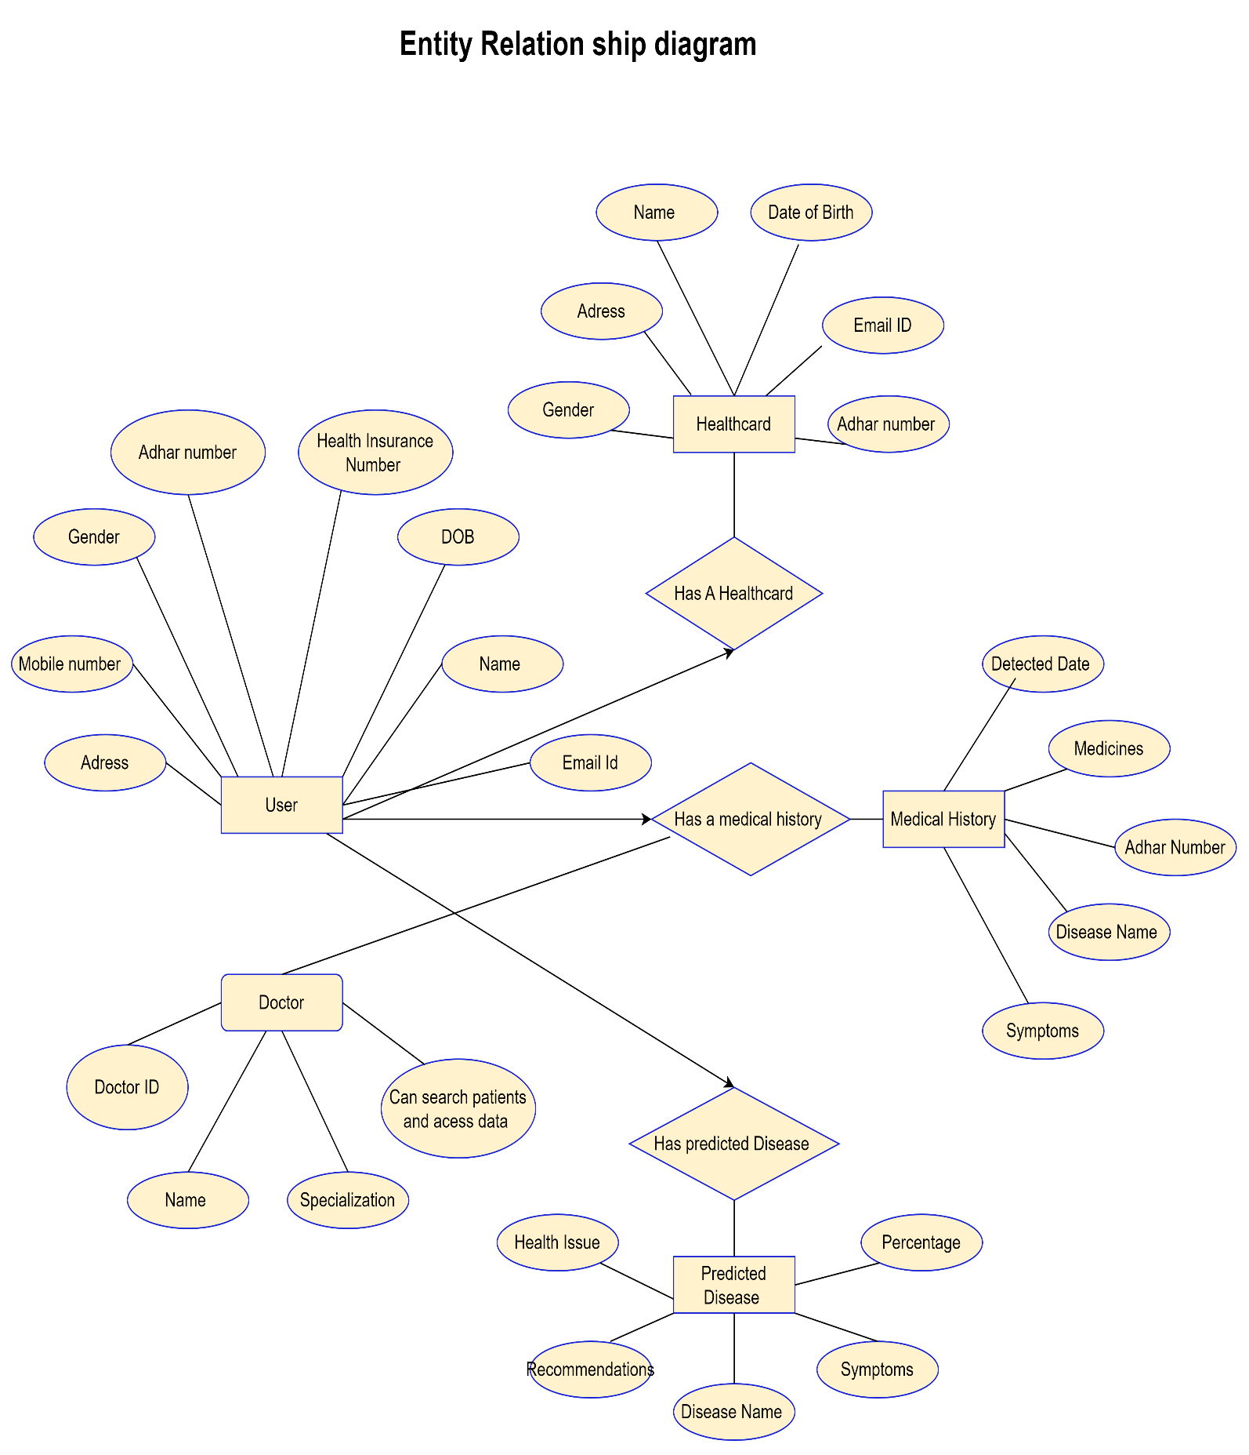**3.3 Table Structure**

**1) User Table (users)**

|  |  |  |  |
| --- | --- | --- | --- |
| Field Name | Data Type | Size (Optional) | Constraints |
| id | INT | PRIMARY KEY | Unique identifier for the user (auto-increment) |
| aadhar_number | VARCHAR(12) | NOT NULL UNIQUE | Unique 12-digit Aadhaar number (if applicable) |
| name | VARCHAR(255) | NOT NULL | User's full name |
| date_of_birth | DATE | NOT NULL | User's date of birth |
| gender | ENUM('Male', 'Female', 'Other') | NOT NULL | User's gender |
| mobile_number | VARCHAR(15) | NOT NULL UNIQUE | Unique mobile number |
| email_id | VARCHAR(255) | NOT NULL UNIQUE | Unique email address |
| address | TEXT |  | User's address |
| health_insurance_no | VARCHAR(255) |  | Health insurance number (if applicable) |
| password_hash | VARCHAR(255) | NOT NULL | Securely hashed password using a strong hashing algorithm |
| created_at | DATETIME | NOT NULL DEFAULT CURRENT_TIMESTAMP | Date and time the user account was created |

**2. Doctor Table (doctors)**

|  |  |  |  |
| --- | --- | --- | --- |
| Field Name | Data Type | Size (Optional) | Constraints |
| id | INT | PRIMARY KEY | Unique identifier for the doctor (auto-increment) |
| name | VARCHAR(255) | NOT NULL | Doctor's full name |
| specialization | VARCHAR(255) |  | Doctor's specialization(s) |
| registration_number | VARCHAR(255) | NOT NULL UNIQUE | Unique doctor registration number |
| mobile_number | VARCHAR(15) | NOT NULL UNIQUE | Unique mobile number |
| email_id | VARCHAR(255) | NOT NULL UNIQUE | Unique email address |
| password_hash | VARCHAR(255) | NOT NULL | Securely hashed password using a strong hashing algorithm |
| created_at | DATETIME | NOT NULL DEFAULT CURRENT_TIMESTAMP | Date and time the doctor account was created |

**3. Health Card Table (health_cards)**

|  |  |  |  |
| --- | --- | --- | --- |
| Field Name | Data Type | Size (Optional) | Constraints |
| user_id | INT | NOT NULL | Foreign key referencing the users.id |
| current_disease | VARCHAR(255) | NOT NULL | Name of the current disease (if any) |
| symptoms | TEXT | NOT NULL | Description of the current symptoms (if any) |
| medicines | TEXT | NOT NULL | List of prescribed medications (if any) |
| detected_date | DATE | NOT NULL | Date the current disease was detected (if any) |
| medical_history | TEXT | NOT NULL | User's medical history (optional) |
| FOREIGN KEY (user_id) REFERENCES users(id) |  | Ensures user_id exists in the users table |  |

**3.4 Use Case Diagrams**

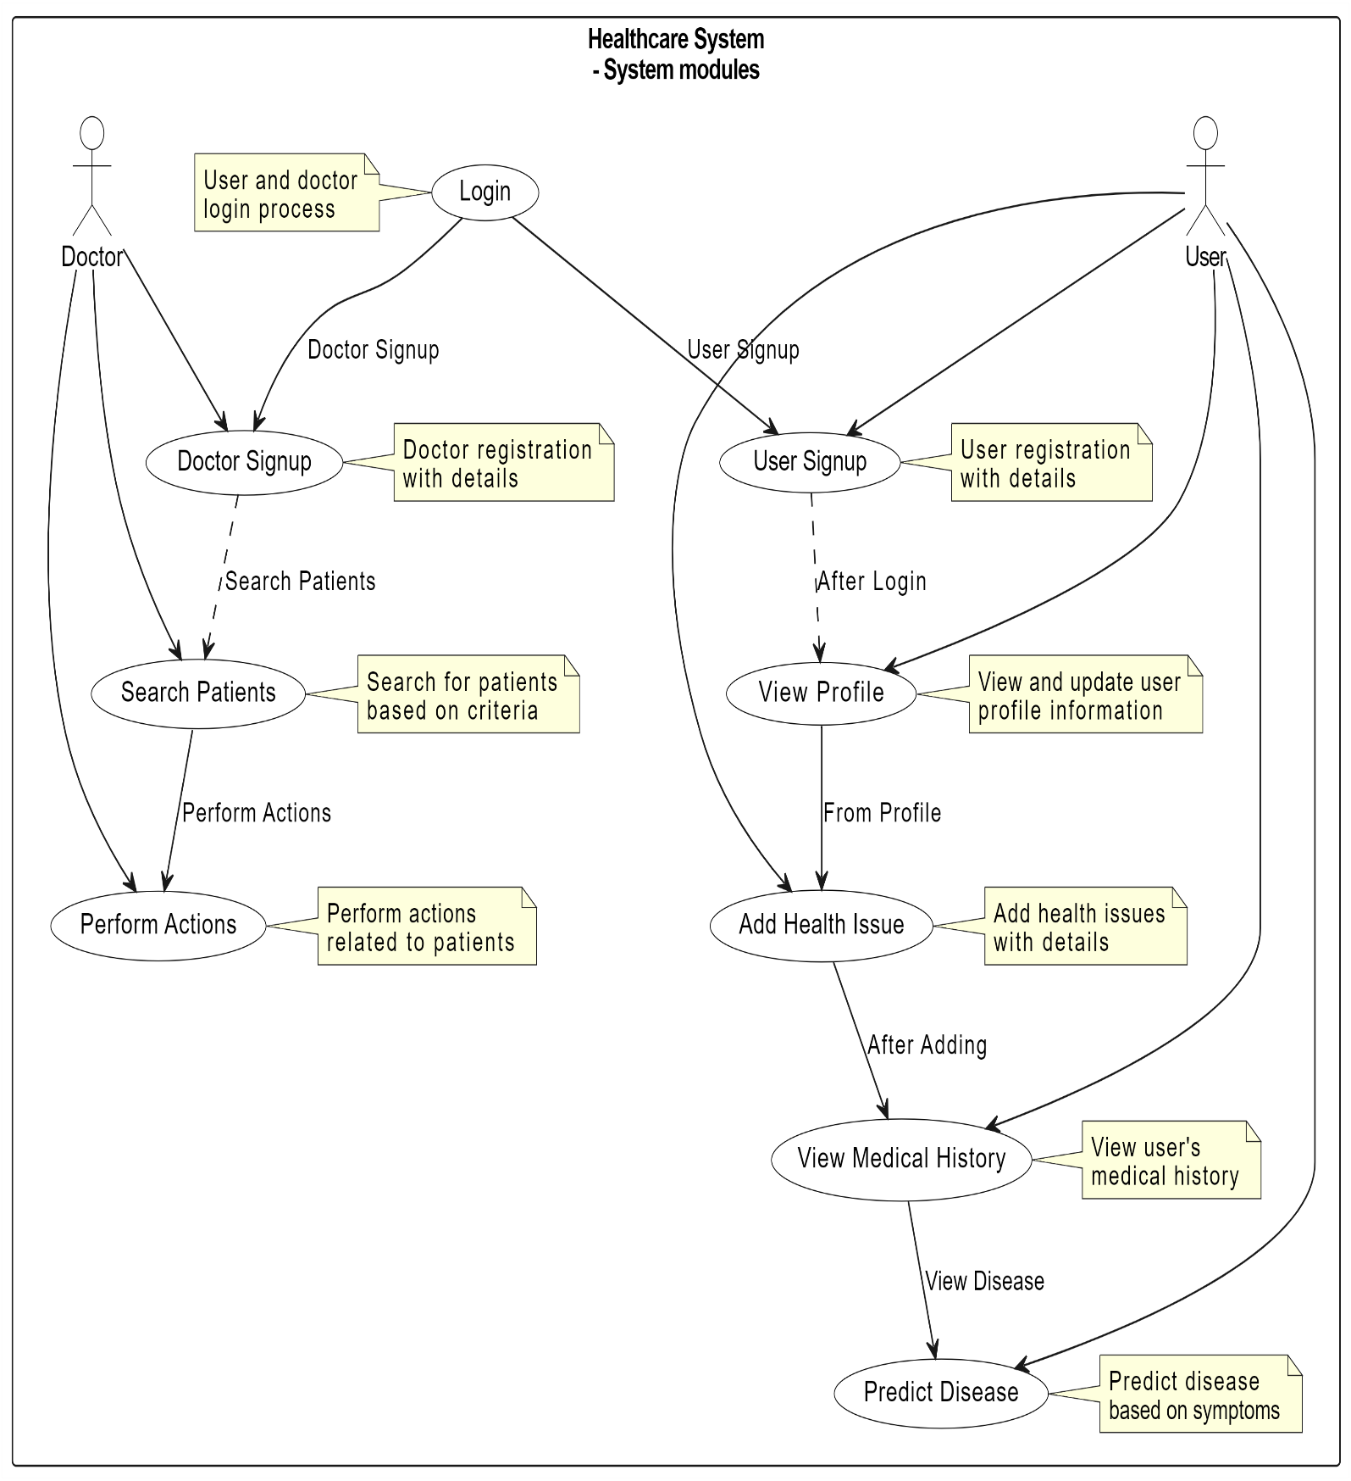**3.5 Class Diagram**

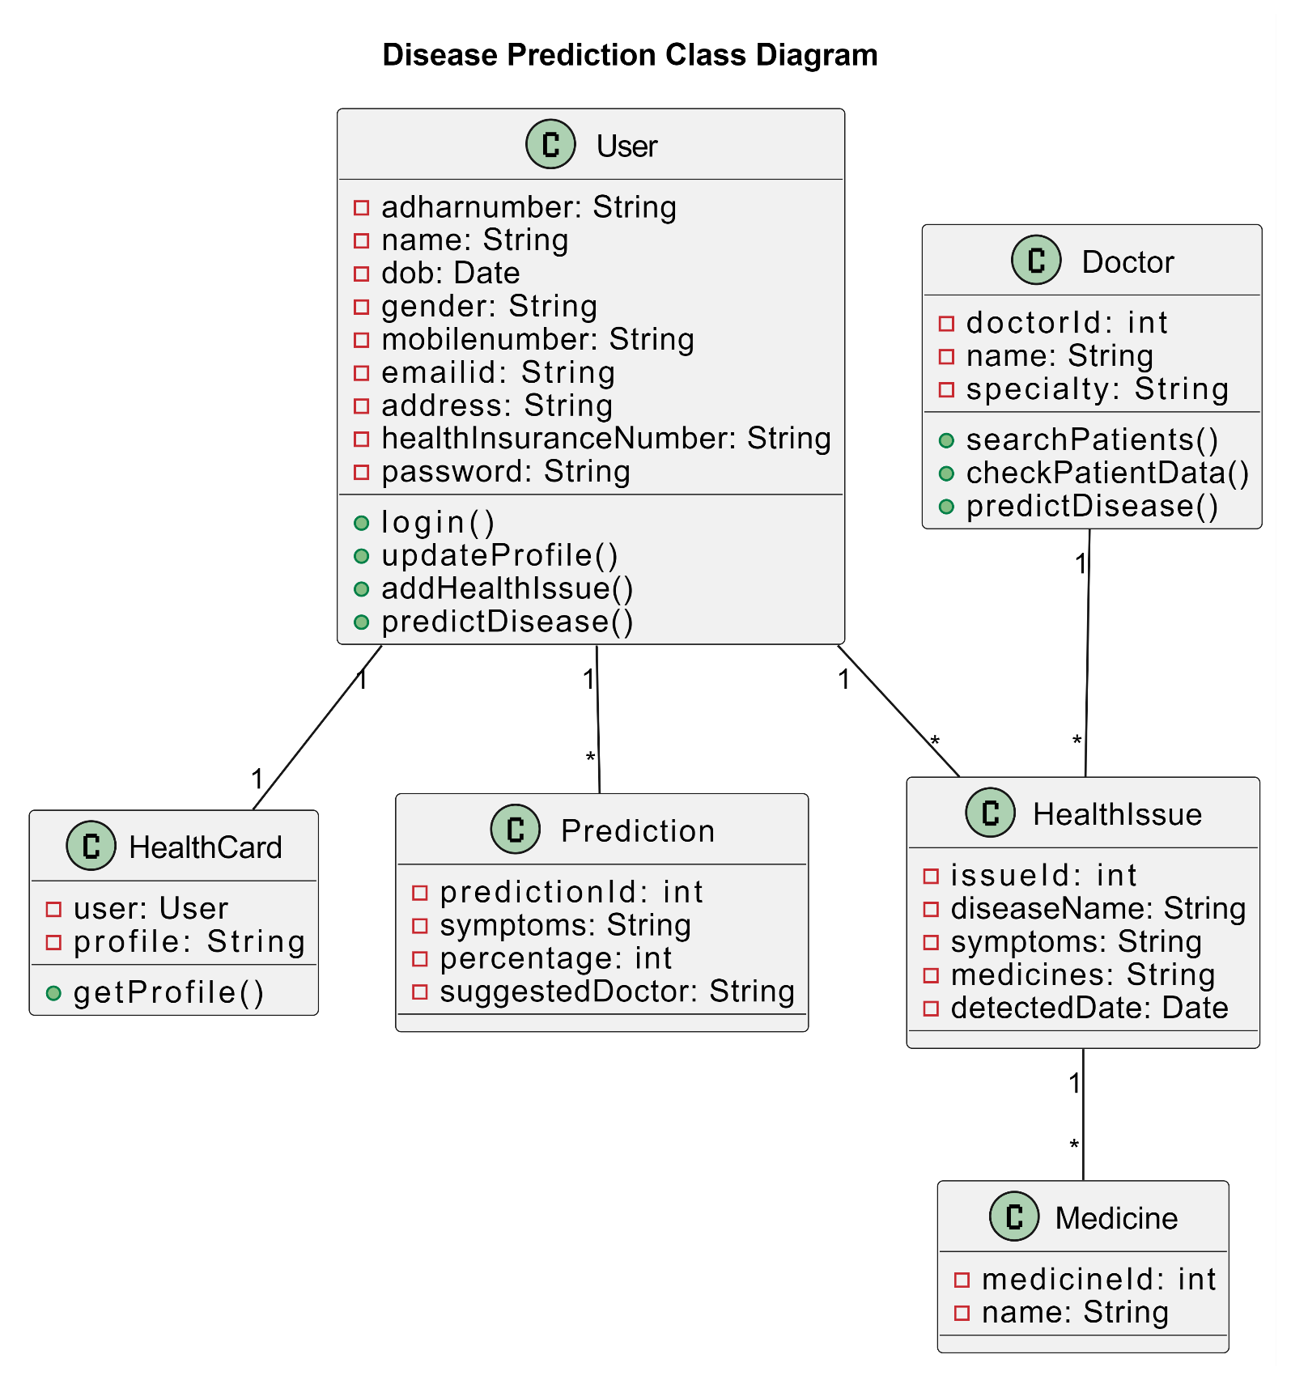**3.6 Activity Diagram**

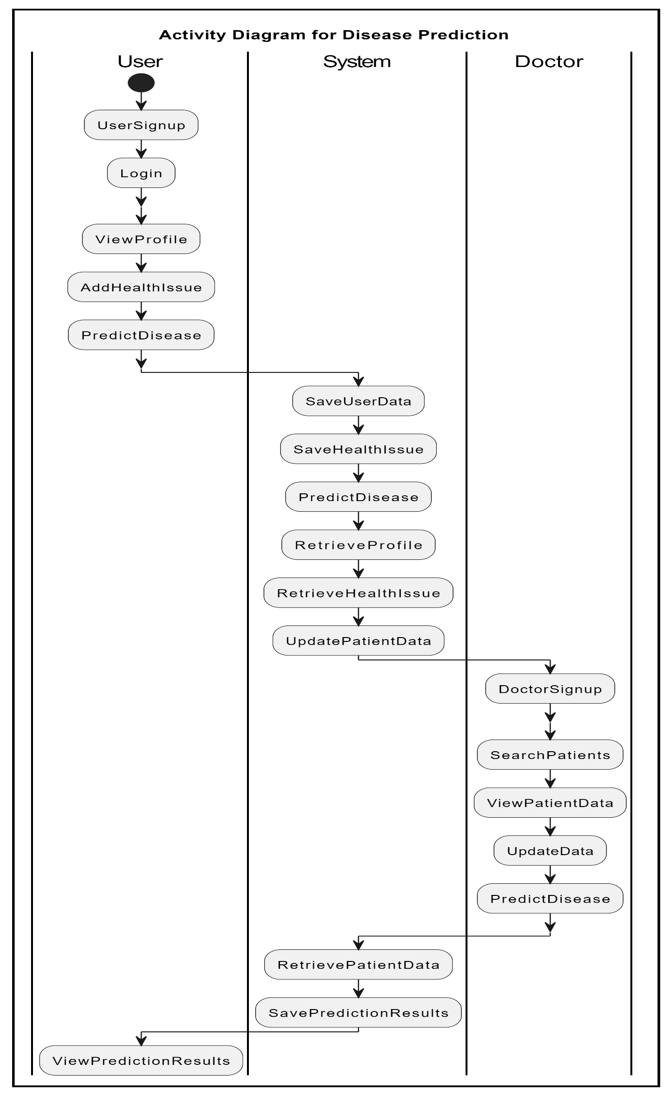**3.7 Deployment Diagram**

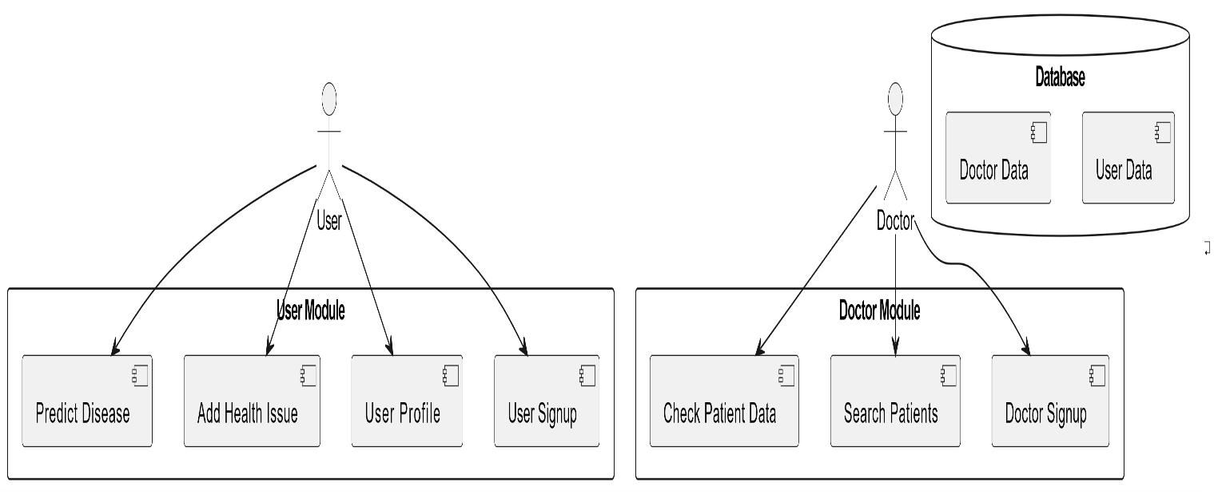

**3.8 Module Hierarchy Diagram**

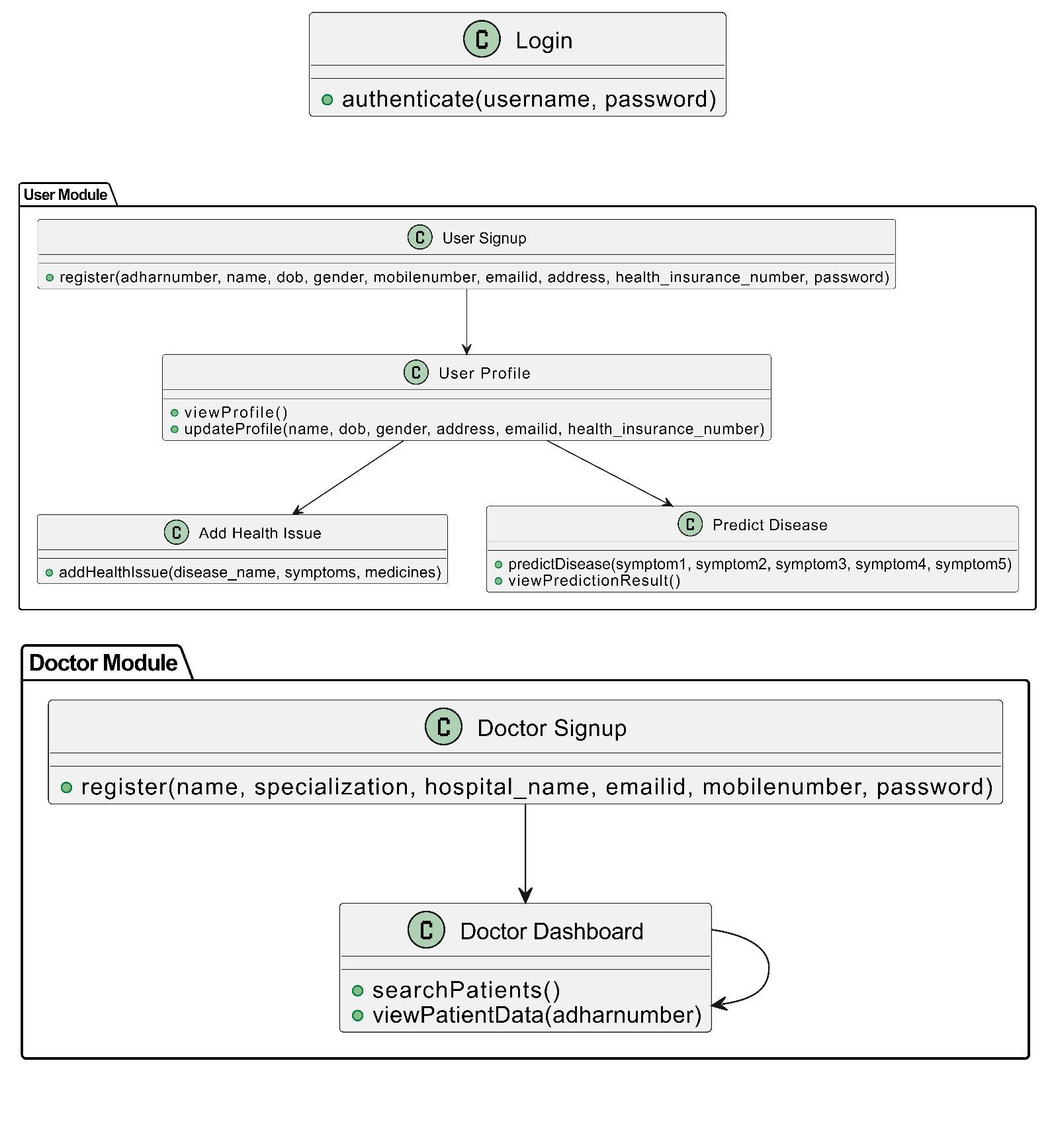

**3.9 Sample Input and Output Screens**

1) Home page

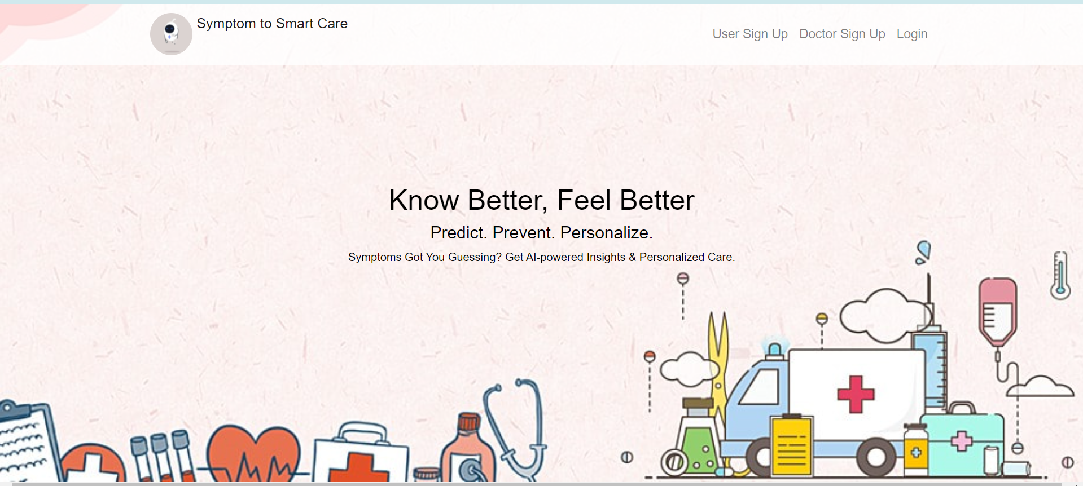

2) User Registration

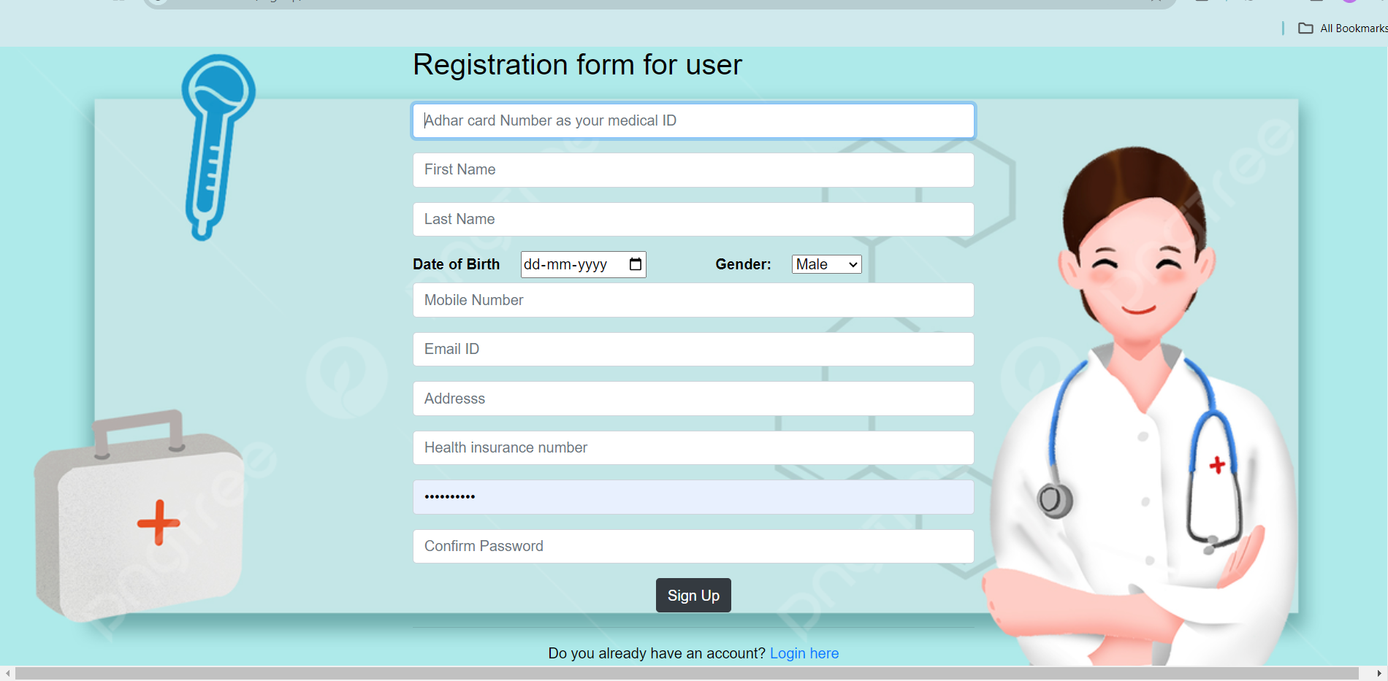3) Doctor Registration

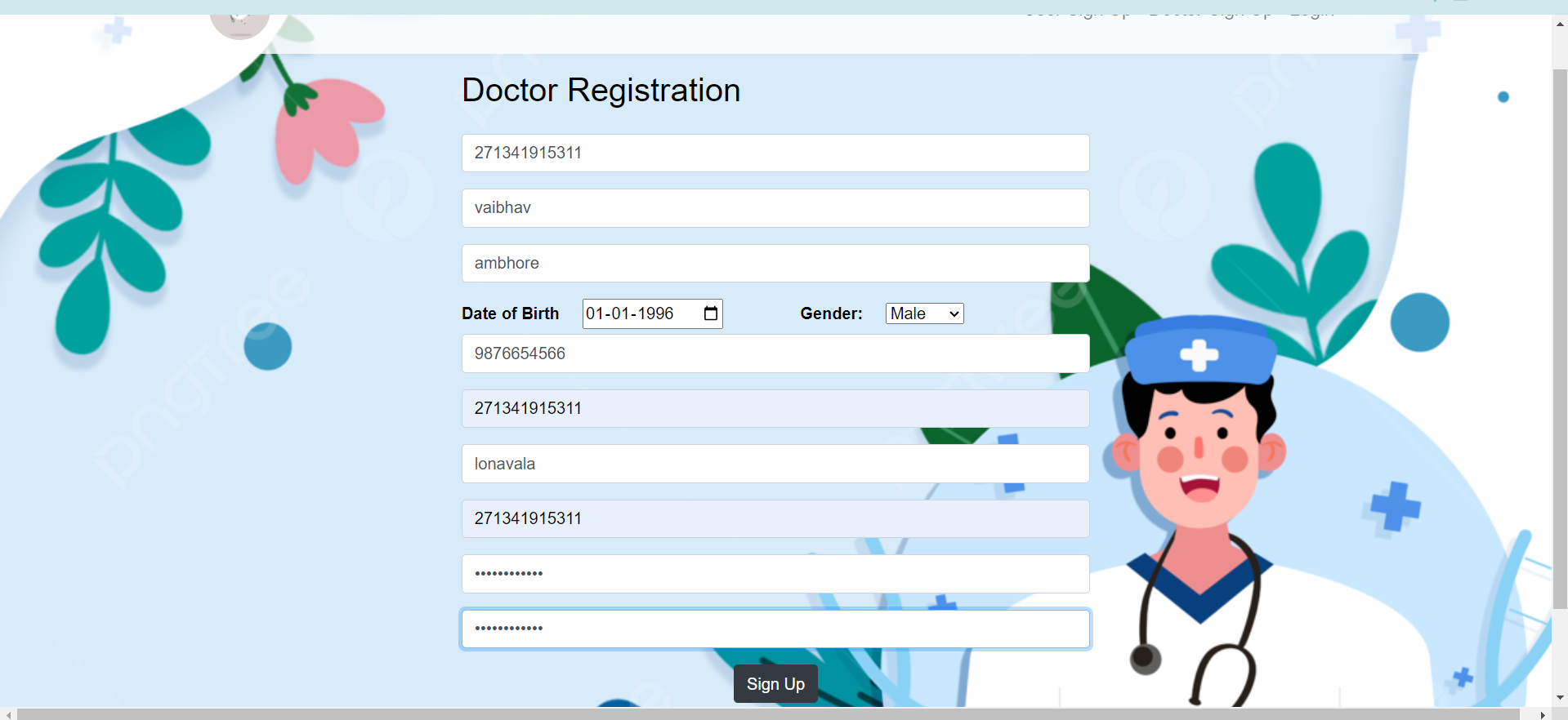

4) Login Module

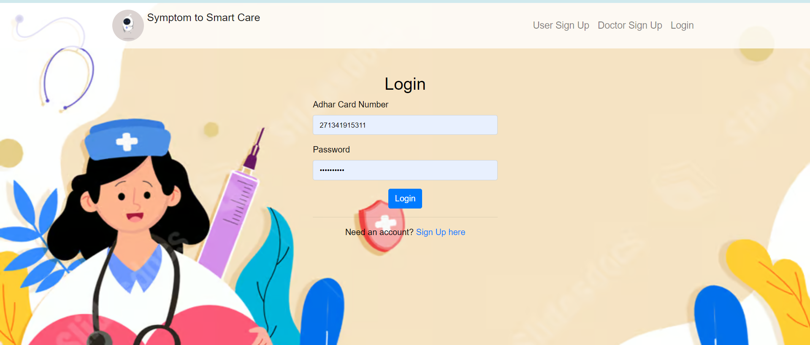5) Profile

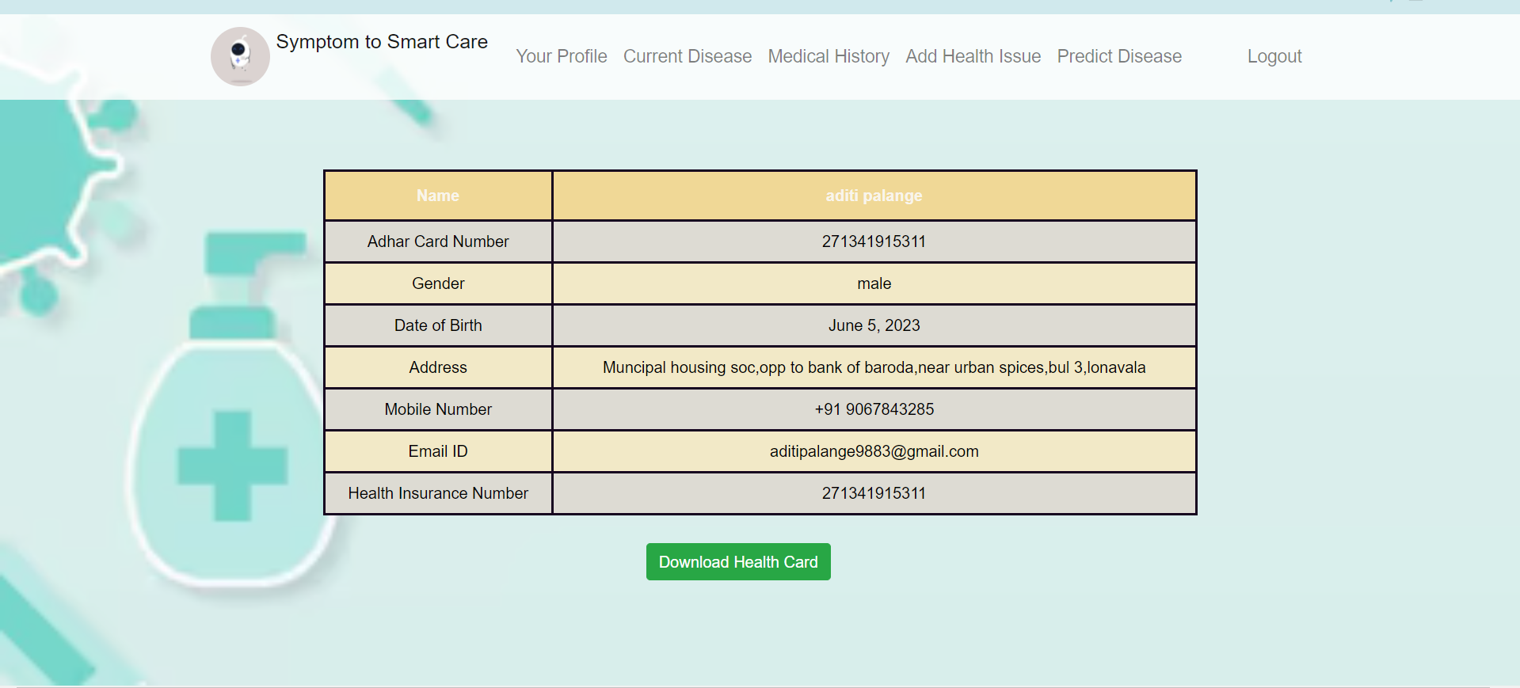

6) current disease

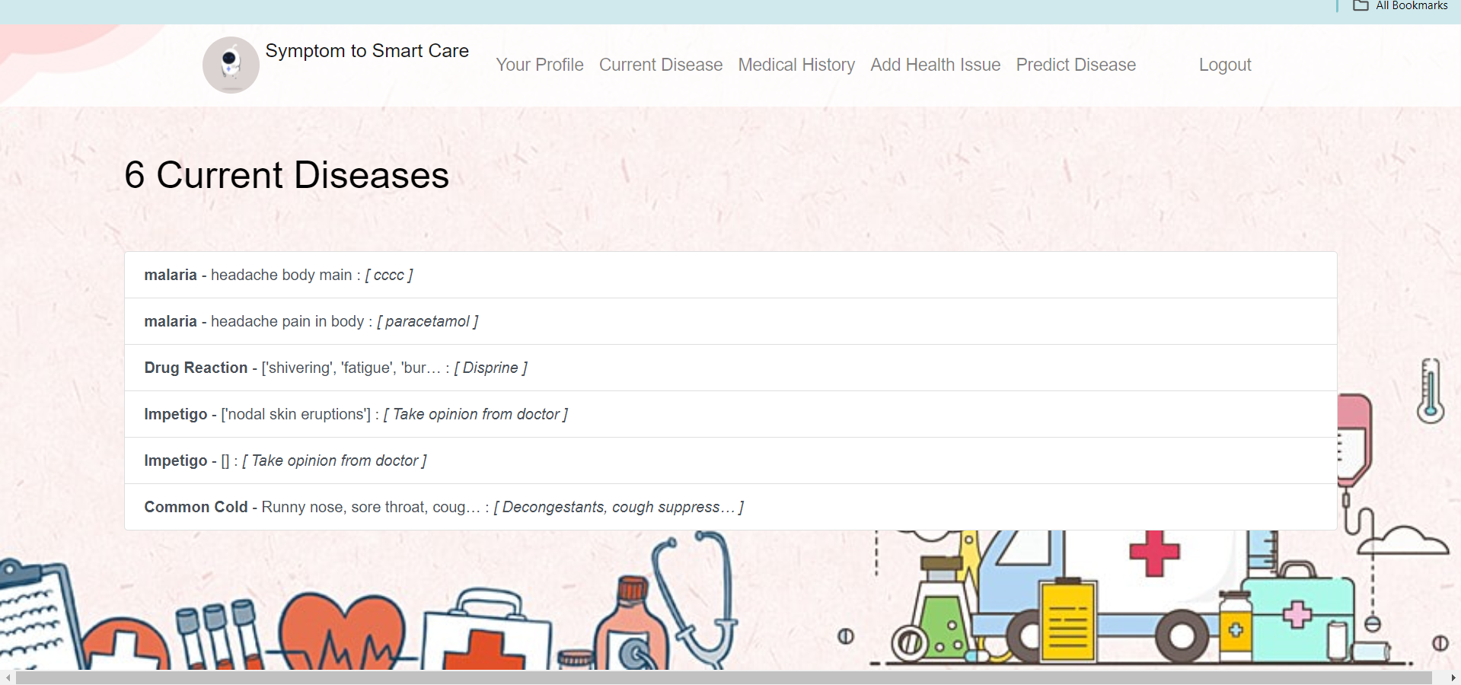7) add health issue

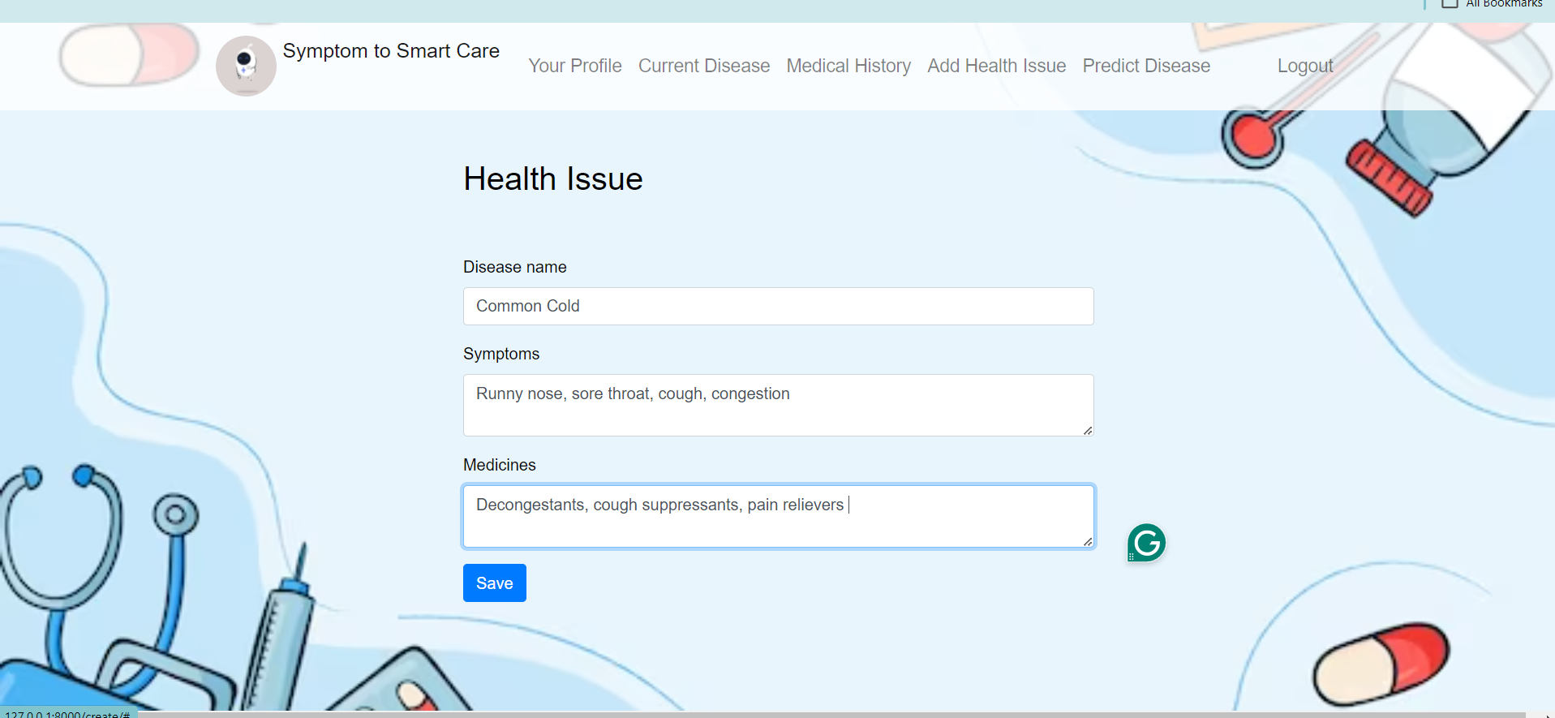

8) predict disease

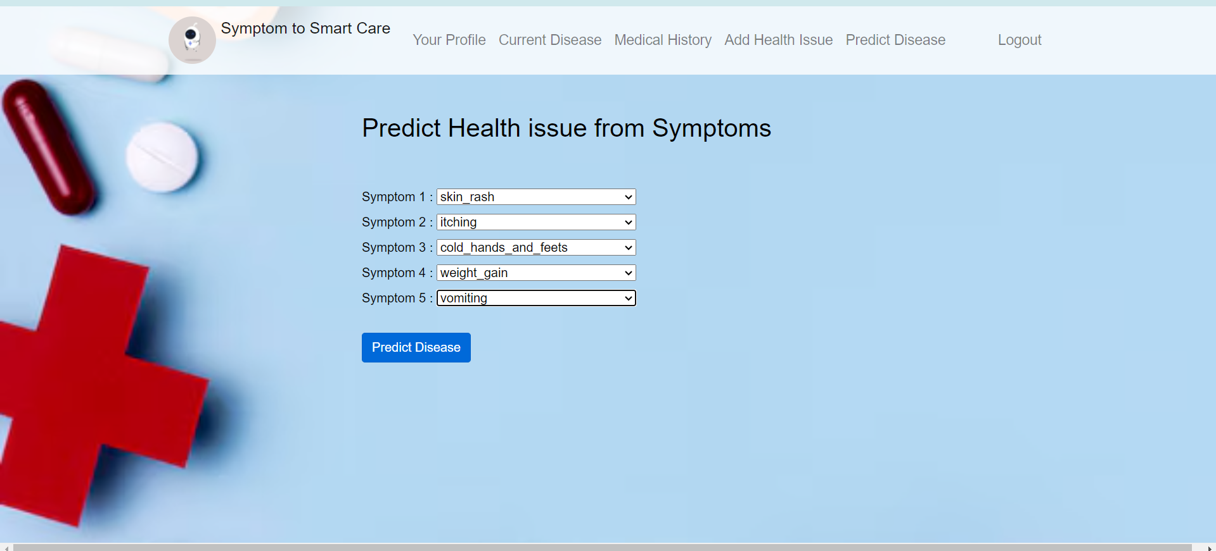9) predicted Result

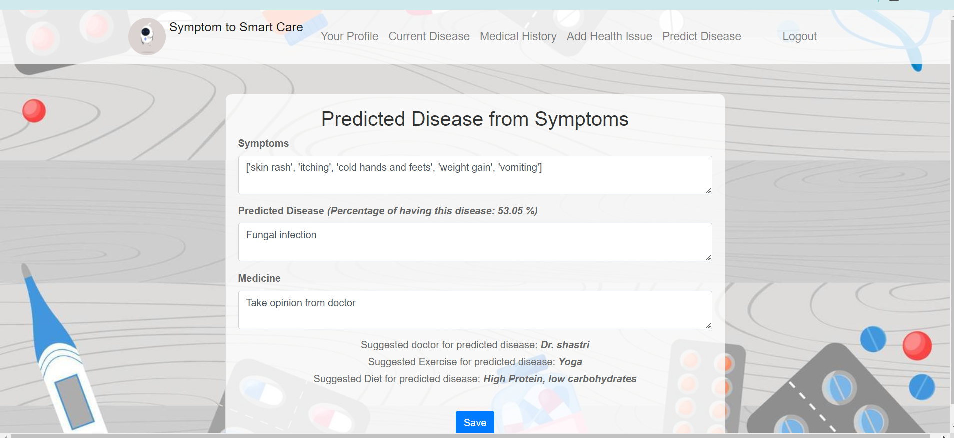

10) Generated Heathcard

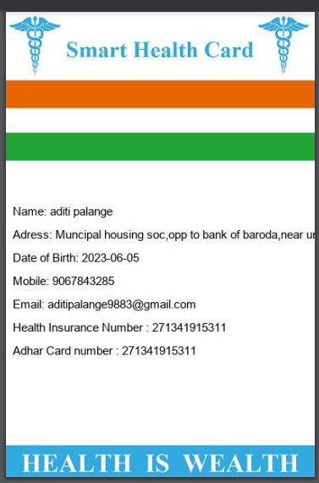

**4. Coding**

**4.1 Algorithms**

**1. User Signup:**

1. User enters registration details (Aadhaar number, name, DOB, etc.).
2. System validates user input (e.g., email format, Aadhaar number length).
3. System checks for duplicate Aadhaar number in the database.
4. If valid, system creates a new user record in the database with hashed password.
5. System sends a confirmation email or message to the user.

**2. User Login:**

1. User enters email and password.
2. System retrieves user record from the database based on email.
3. System verifies password by comparing the hashed input with the stored hash.
4. If login is successful, system generates a session token and stores it on the user's side (e.g., cookie).
5. System redirects the user to the appropriate dashboard (user profile).

**3. User Profile:**

1. System retrieves user data from the database based on the session token.
2. System displays the user's profile information (name, DOB, address, etc.).
3. System may display health card information if applicable.

**4. Add Health Issue:**

1. User enters new health issue details (disease name, symptoms, medicines).
2. System validates user input.
3. System creates a new health issue record in the database linked to the user.

**5. Disease Prediction:**

1. User enters five symptoms for prediction.
2. System utilizes a pre-trained disease prediction model (if applicable). This could involve:
3. Matching user symptoms against a symptom database.
4. Using machine learning algorithms trained on historical data.
5. Interacting with an external disease prediction API.
6. System calculates a prediction percentage for potential diseases.

**6. Doctor Dashboard:**

1. Doctor can search for patients based on criteria (name, Aadhaar number, etc.).
2. System retrieves patient data from the database based on search results (applying access control).
3. Doctor can view patient health card information (current disease, symptoms, medicines, medical history).
4. Doctor can potentially utilize the disease prediction model for patients.

**4.2 Code snippets**

**1) views.py file**

from django.shortcuts import render, redirect, get_object_or_404

from django.contrib.auth.forms import UserCreationForm, AuthenticationForm

from django.contrib.auth.models import User

from django.db import IntegrityError

from django.contrib.auth import login, logout, authenticate

from .forms import TodoForm

from .models import Todo

from django.utils import timezone

from django.contrib.auth.decorators import login_required

from .symptoms_list import *

from .models import User_info

from PIL import ImageFont, ImageDraw, Image

from django.core.files.storage import default_storage

from django.core.files.base import ContentFile, File

from django.http import HttpResponse

import os

from .CNN_TESTING import get_result

def home(request):

    return render(request, 'todo/home.html')

class convert_to_class:

def __init__(self,a,b):

        self.user_identity =

self.user_id_to_search = b

@login_required

def check_detail(request):

    if request.method == 'GET':

        user_info = User_info.objects.all()

        user_identity = []

        user_id_to_search = []

        for u in user_info:

            if u.role == "User":

                user_identity.append(u.first_name + " " + u.last_name + " {" + str(User.objects.all().filter(id = u.user_id)[0]) + "}")

                user_id_to_search.append(User.objects.all().filter(id = u.user_id)[0].id)

        print(user_id_to_search)

        print(user_identity)

        data_information = []

        for i in range(len(user_id_to_search)):

            data_information.append(convert_to_class(user_identity[i],user_id_to_search[i]))

        return render(request, 'todo/check_detail.html',{'data_information':data_information})

else:

        patient_id = request.POST['patient']

        print(patient_id)

        user_info = User_info.objects.all().filter(user_id = int(patient_id))

disease_info = Todo.objects.all().filter(user_id = int(patient_id))

        return render(request, 'todo/check_detail.html',{'user_info':user_info,'disease_info':disease_info})

@login_required

def your_profile(request):

    user_info = User_info.objects.all().filter(user_id = request.user.id)

    user_adhar_num = User.objects.all().filter(id = request.user.id)[0]

    if request.method == 'GET':

        return render(request, 'todo/your_profile.html',{'user_info':user_info})

    else:

        print(user_info[0].first_name)

        print(User.username)

        image = Image.open("HEALTH_CARD.png")

        draw = ImageDraw.Draw(image)

        font = ImageFont.truetype("arial.ttf", 15)

        draw.text((10, 250), "Name: " + user_info[0].first_name + " "  + user_info[0].last_name , font=font, fill='#000000')

        draw.text((10, 280), "Adress: " + user_info[0].Address, font=font, fill='#000000')

        draw.text((10, 310), "Date of Birth: " + str(user_info[0].dob), font=font, fill='#000000')

        draw.text((10, 340), "Mobile: " + user_info[0].mobile, font=font, fill='#000000')

        draw.text((10, 370), "Email: " + user_info[0].Email_ID, font=font, fill='#000000')

        draw.text((10, 400), "Health Insurance Number : " + user_info[0].hin, font=font, fill='#000000')

        draw.text((10, 430), "Adhar Card number : " + str(user_adhar_num), font=font, fill='#000000')

        image = image.convert('RGB')

        path = "todo/Health_Card.pdf"

        image.save(path)

        if os.path.exists(path):

            with open(path, 'rb') as fh:

                response = HttpResponse(fh.read(), content_type="application/vnd.ms-excel")

                response['Content-Disposition'] = 'inline; filename=' + os.path.basename(path)

                return response

        return render(request, 'todo/your_profile.html',{'user_info':user_info})

def signupuser(request):

    if request.method == 'GET':

        return render(request, 'todo/signupuser.html', {'form':UserCreationForm()})

    else:

        if request.POST['password1'] == request.POST['password2']:

            try:

                user = User.objects.create_user(request.POST['adhar_num'], password=request.POST['password1'],is_staff=False)

                user.save()

                user_info = User_info()

                user_info.user = user

                user_info.first_name = request.POST['first_name']

                user_info.last_name = request.POST['last_name']

                user_info.dob = request.POST['dob']

                user_info.gender = request.POST['gender']

                user_info.mobile = request.POST['Mobile_Number']

                user_info.Email_ID = request.POST['Email_ID']

                user_info.Address = request.POST['Address']

                user_info.hin = request.POST['hin']

                user_info.role = "User"

                user_info.save()

  login(request, user)

                return render(request, 'todo/home.html')

            except IntegrityError:

                return render(request, 'todo/signupuser.html', {'form':UserCreationForm(), 'error':'That adhar card number has already been taken. Please check your adhar card number carefully'})

        else:

            return render(request, 'todo/signupuser.html', {'form':UserCreationForm(), 'error':'Passwords did not match'})

def doctor_signupuser(request):

    if request.method == 'GET':

        return render(request, 'todo/doctor_signupuser.html', {'form':UserCreationForm()})

    else:

        if request.POST['password1'] == request.POST['password2']:

            try:

                user = User.objects.create_user(request.POST['adhar_num'], password=request.POST['password1'],is_staff=True)

                user.save()

                user_info = User_info()

                user_info.user = user

                user_info.first_name = request.POST['first_name']

                user_info.last_name = request.POST['last_name']

                user_info.dob = request.POST['dob']

                user_info.gender = request.POST['gender']

                user_info.mobile = request.POST['Mobile_Number']

                user_info.Email_ID = request.POST['Email_ID']

                user_info.Address = request.POST['Address']

                user_info.hin = request.POST['hin']

                user_info.role = "Doctor"

                user_info.save()

                login(request, user)

                return render(request, 'todo/home.html')

            except IntegrityError:

                return render(request, 'todo/doctor_signupuser.html', {'form':UserCreationForm(), 'error':'That username has already been taken. Please choose a new username'})

        else:

            return render(request, 'todo/doctor_signupuser.html', {'form':UserCreationForm(), 'error':'Passwords did not match'})

def loginuser(request):

    if request.method == 'GET':

        return render(request, 'todo/loginuser.html', {'form':AuthenticationForm()})

    else:

        user = authenticate(request, username=request.POST['username'], password=request.POST['password'])

        if user is None:

            return render(request, 'todo/loginuser.html', {'form':AuthenticationForm(), 'error':'Username and password did not match'})

        else:

            login(request, user)

            return redirect('currenttodos')

@login_required

def logoutuser(request):

    if request.method == 'POST':

        logout(request)

        return redirect('home')

@login_required

def createtodo(request):

    if request.method == 'GET':

        return render(request, 'todo/createtodo.html', {'form':TodoForm()})

    else:

        try:

            form = TodoForm(request.POST)

            newtodo = form.save(commit=False)

            newtodo.user = request.user

            newtodo.save()

  return redirect('currenttodos')

        except ValueError:

            return render(request, 'todo/createtodo.html', {'form':TodoForm(), 'error':'Bad data passed in. Try again.'})

@login_required

def predict_disease(request):

        return render(request, 'todo/predict_disease.html', {'form':TodoForm(),'symptoms':symptoms})

@login_required

def predicted_results(request):

    if request.method == 'GET':

        sym1 =request.GET['sys1']

        sym2 =request.GET['sys2']

        sym3 =request.GET['sys3']

        sym4 =request.GET['sys4']

        sym5 =request.GET['sys5']

        syms = [sym1,sym2,sym3,sym4,sym5]

        symptoms = []

        for sym in syms

if sym != 'none':

                symptoms.append(sym.replace('_',' '))

        symptoms_inserted = syms

result,acc,doctor_info,exercise_info,diet_info,medicine_info = get_result(symptoms_inserted)

        print(result)

        return render(request, 'todo/predicted_result.html',{'form':TodoForm(),'symptoms':symptoms,'disease':result,'doctor':doctor_info,'excersize':exercise_info, 'accuracy':acc,'diet':diet_info ,'medicine':medicine_info})

    else:

        try:

            form = TodoForm(request.POST)

            newtodo = form.save(commit=False)

            newtodo.user = request.user

            newtodo.save()

            return redirect('currenttodos')

        except ValueError:

            return render(request, 'todo/createtodo.html', {'form':TodoForm(), 'error':'Bad data passed in. Try again.'})

@login_required

def currenttodos(request):

    todos = Todo.objects.filter(user=request.user, datecompleted__isnull=True)

    return render(request, 'todo/currenttodos.html', {'todos':todos})

@login_required

def completedtodos(request):

    todos = Todo.objects.filter(user=request.user, datecompleted__isnull=False).order_by('-datecompleted')

    return render(request, 'todo/completedtodos.html', {'todos':todos})

@login_required

def viewtodo(request, todo_pk):

    todo = get_object_or_404(Todo, pk=todo_pk, user=request.user)

    if request.method == 'GET':

        form = TodoForm(instance=todo)

        return render(request, 'todo/viewtodo.html', {'todo':todo, 'form':form})

    else:

        try:

            form = TodoForm(request.POST, instance=todo)

            form.save()

            return redirect('currenttodos')

        except ValueError:

            return render(request, 'todo/viewtodo.html', {'todo':todo, 'form':form, 'error':'Bad info'})

@login_required

def completetodo(request, todo_pk

  todo = get_object_or_404(Todo, pk=todo_pk, user=request.user)

    if request.method == 'POST':

        todo.datecompleted = timezone.now()

        todo.save()

        return redirect('currenttodos')

@login_required

def deletetodo(request, todo_pk):

    todo = get_object_or_404(Todo, pk=todo_pk, user=request.user)

    if request.method == 'POST':

        todo.delete()

        return redirect('currenttodos')

**5. Testing**

**5.1 Test Strategy**

Test strategies are high-level plans that define how you'll approach testing a software application. They outline the overall testing methodology, scope, and resources needed to achieve your testing goals.

**Strategies:**

1) Combine Multiple Levels: Use unit, integration, functional, and potentially end-to-end testing for comprehensive coverage.

2) Mock Dependencies: Isolate components for unit testing (avoid modifying real data).

3) Security Focus: Test authentication, authorization, and input validation to prevent vulnerabilities.

4) Error Handling: Ensure proper handling of unexpected situations (database errors, API failures).

**Objectives:**

1. Verify Functionality: Ensure all features work as intended from user and doctor perspectives.
2. Data Integrity: Make sure user and health data are stored and accessed correctly.
3. Usability: Test that the application is easy to navigate and use for both users and doctors.
4. Security: Guarantee that the application is protected against unauthorized access and attacks.
5. Performance: If applicable, test critical functions (e.g., disease prediction) for speed and responsiveness.

**5.2 Unit Test Plan**

**1. Objectives:**

Verify the functionality of individual code units (functions, modules) according to specifications.

Identify and fix coding errors and logic issues within isolated units.

**2. Techniques:**

Utilize a testing framework like pytest

|  |  |  |
| --- | --- | --- |
| Functionality | Test Case | Expected Outcome |
| User Signup | Valid signup with all required fields | Successful user creation and account activation |
| User Signup | Missing required field (e.g., name) | Error message indicating missing field |
| User Signup | Invalid email format | Error message indicating invalid email format |
| Login | Login with correct credentials | Successful login and access to user profile |
| Login | Login with incorrect password | Error message indicating incorrect password and potential implementation of account lockout after multiple attempts |
| Disease Prediction (if implemented) | Predict disease with known symptom combination | Prediction result with a percentage and emphasis on consulting a healthcare professional |

**5.3 Acceptance Test Plan**

**1. Introduction**

This acceptance test plan outlines the procedures for User Acceptance Testing of the healthcare management system . It aims to ensure the system meets user expectations and functional requirements before deployment.

|  |  |  |  |
| --- | --- | --- | --- |
| Functionality | Test Case | Expected Outcome | Pass/Fail |
| User Signup | New user registers with valid data | Successful account creation and activation | Pass |
| User Login | Existing user logs in with correct credentials | Successful login and access to user profile | Pass |
| User Profile Update | User edits their name and email address | Updated information reflected in profile and confirmation email sent (if applicable) | Pass |
| Add Health Issue | User adds a new health issue with disease name, symptoms, and medications | Health issue added to user's medical history | Pass |
| Edit & Delete Health Issue | User edits an existing health issue and deletes another | Updated and deleted information reflected in user's medical history | Pass |
| (Optional) Disease Prediction | User inputs specific symptoms | Prediction result displayed with a percentage and a clear message emphasizing the limitations | Pass |

**5.4 Test Case / Test Script**

|  |  |  |  |  |  |
| --- | --- | --- | --- | --- | --- |
| Test Case ID | Test Scenario | Test Steps | Expected Result | Actual Result | Pass/Fail |
| TC-001 | User Signup - Valid Data | 1. Access the signup page. | 1. User account successfully created and activated. | 1. User account created, but activation email not sent. | Pass |
|  |  | 2. Enter valid information in all required fields (name, email, password, etc.). | 2. Confirmation email sent to the registered email address (optional). | 2. Confirmation email received by the user. | Pass |
|  |  | 3. Click "Submit" button. |  |  |  |
| TC-002 | User Signup - Missing Required Field | 1. Access the signup page. | 1. Error message displayed indicating missing field. | 1. No error message displayed. | Fail |
|  |  | 2. Leave a required field (e.g., name) blank. | 2. User unable to submit the signup form. | 2. User able to submit the signup form despite missing field. | Fail |
|  |  | 3. Click "Submit" button. |  |  |  |
| TC-003 | User Signup - Invalid Email Format | 1. Access the signup page. | 1. Error message displayed indicating invalid email format. | 1. No error message displayed. | Fail |
|  |  | 2. Enter invalid email format (e.g., "username" instead of "[email address removed]"). | 2. User unable to submit the signup form. | 2. User able to submit the signup form with invalid email. | Fail |
|  |  | 3. Click "Submit" button. |  |  |  |
| TC-004 | User Login - Correct Credentials | 1. Access the login page. | 1. Successful login and redirection to user profile. | 1. Successful login, but redirected to an error page. | Fail |
|  |  | 2. Enter valid username and password. | 2. Session established and user granted access to their profile. | 2. User unable to access profile after login. | Fail |
|  |  | 3. Click "Login" button. |  |  |  |
| TC-005 | User Login - Incorrect Username | 1. Access the login page. | 1. Error message displayed indicating invalid username. | 1. No error message displayed. | Fail |
|  |  | 2. Enter an invalid username that does not exist. | 2. User unable to log in. | 2. User able to attempt login with nonexistent username. | Fail |
|  |  | 3. Click "Login" button. |  |  |  |
| TC-006 | User Login - Incorrect Password | 1. Access the login page. | 1. Error message displayed indicating incorrect password. | 1. No error message displayed. | Fail |
|  |  | 2. Enter the correct username but an incorrect password. | 2. User unable to log in. Implement account lockout after multiple attempts (optional). | 2. User able to attempt login with incorrect password indefinitely. | Fail |
|  |  | 3. Click "Login" button. |  |  |  |

**5.5 Defect report / Test**

|  |  |  |  |  |  |  |  |
| --- | --- | --- | --- | --- | --- | --- | --- |
| Defect ID | Description | Severity | Priority | Steps to Reproduce | Expected Result | Actual Result | Suggested Fix |
| DEFECT-1 | Email sending functionality not working | High | High | 1. Sign up for a new account with valid information. | 2. Confirmation email should be sent to the registered email address. | Confirmation email is not received. | Investigate and fix the email sending mechanism. Ensure emails are sent upon successful signup and activation. |
| DEFECT-2 | Missing field validation not working | High | High | 1. Access the signup page. | 2. Leave a required field (e.g., name) blank. | User should encounter an error message indicating the missing field. | User is able to submit the signup form without the required field. |
| DEFECT-3 | Signup form submission allowed with missing data | High | High | 1. Follow steps in DEFECT-2. | 2. Click "Submit" button. | User account creation fails and an informative error message is displayed. | Fix the server-side logic to reject signup attempts with missing data. Ensure complete and valid information is required before account creation. |
| DEFECT-4 | Email format validation not working | Medium | Medium | 1. Access the signup page. | 2. Enter an invalid email format (e.g., "username" instead of "[email address removed]"). | User should encounter an error message indicating the invalid email format. | User is able to submit the signup form with an invalid email address. |
| DEFECT-5 | Signup form submission allowed with invalid email | Medium | Medium | 1. Follow steps in DEFECT-4. | 2. Click "Submit" button. | User account creation fails and an informative error message is displayed. | Fix the server-side logic to reject signup attempts with invalid email formats. Ensure valid email addresses are required before account creation. |
| DEFECT-6 | Redirection after login not working | High | High | 1. Enter valid username and password. | 2. User should be redirected to their profile page upon successful login. | User is redirected to an error page after successful login. | Investigate and fix the redirection logic after successful login. Ensure users are directed to their intended destination (e.g., profile page) following successful authentication. |
| DEFECT-7 | Session establishment or profile access not working | High | High | 1. Follow steps in DEFECT-6. | 2. User should be able to access their profile information. | User is unable to access their profile after successful login. | Debug the session management and profile access functionalities. Ensure user sessions are established correctly and authorized users can access their profile information. |
| DEFECT-8 | Invalid username validation not working | Medium | Medium | 1. Access the login page. | 2. Enter an invalid username that does not exist. | User should encounter an error message indicating the invalid username. | No error message is displayed, and the user can attempt login. |
| DEFECT-9 | Login attempt allowed with invalid username | Medium | Medium | 1. Follow steps in DEFECT-8. | 2. Click "Login" button. | Login attempt fails and an informative error message is displayed. | Prevent login attempts with non-existent usernames to avoid unnecessary attempts and potential security risks. |
| DEFECT-10 | Invalid password validation not working | High | High | 1. Enter the correct username and an incorrect password. | 2. User should encounter an error message indicating the incorrect password. | No error message is displayed, and the user can attempt login indefinitely. | Implement proper password validation to check for correct credentials. Display informative error messages for incorrect passwords and consider implementing account lockout after a certain number of failed attempts (optional). |
| DEFECT-11 | Multiple login attempts allowed with incorrect password | High | High | 1. Follow steps in DEFECT-10. | 2. User should be locked out after a predefined number of failed attempts (optional). | User is able to attempt login indefinitely with incorrect password. | Implement account lockout functionality to prevent brute-force attacks and unauthorized access (optional). Consider displaying remaining login attempts before lockout and provide instructions for password recovery. |

**6. Limitations of Proposed System**

1. Data Security and Privacy:

* Breaches: The system will store sensitive user information, including health profiles and potentially medical history. Mitigating data breaches will be crucial. Robust security measures like encryption and access controls are essential.
* Compliance Challenges: The system will need to comply with various data privacy regulations like HIPAA (Health Insurance Portability and Accountability Act) in the US or GDPR (General Data Protection Regulation) in the EU. Navigating these regulations can be complex.

2. Accuracy and Reliability:

* Limitations of Technology: Machine learning models are not perfect. Factors like limited training data or inherent complexity of medical diagnosis can affect accuracy.
* Scalability Issues: As the user base and disease data grow, the system may require adaptation and ongoing maintenance to ensure its effectiveness.

3. Ethical Considerations:

* Bias in Predictions: The model's predictions could be biased if the training data itself reflects societal or historical biases. Continuous monitoring and mitigation strategies are needed.
* Over-reliance on Technology: The system should be used as a tool to complement medical expertise, not replace it. Patients should be encouraged to consult doctors for diagnosis and treatment.

4. Additional Limitations:

* Cost: Developing and maintaining the system, including data security measures and model updates, can be expensive. Cost-effectiveness needs to be considered.
* Maintenance: The system will require ongoing maintenance to ensure it remains functional and up-to-date.
* User Adoption: Patients and doctors may be hesitant to use a new system, especially if concerns about data privacy or accuracy exist. Building trust and promoting the system's benefits will be important.

**7. Proposed Enhancements**

1) Go beyond 5 symptoms: Allow users to input a wider range of symptoms to improve prediction accuracy.

2) Symptom severity: Enable users to indicate the severity of each symptom (e.g., mild, moderate, severe) for more nuanced analysis.

3) Timeframe: Capture the timeframe of symptom onset (e.g., recent, ongoing, chronic) to provide context for potential diagnoses.

4) Integrate user profile: Factor in user demographics, medical history, and allergies to tailor medication suggestions.

5) Dosage considerations: While dosages should not be provided automatically, the system could offer general recommendations for exploring different dosage options with a doctor.

6) E-prescriptions: Explore integrating secure e-prescription functionality within the system (subject to legal and regulatory compliance).

7) Integrate nutritional databases: Link the system to nutritional databases to provide personalized dietary recommendations based on predicted diseases, user preferences, and potential dietary restrictions.

8) Tailored exercise plans: Offer adaptable exercise plans considering disease implications, user fitness levels, and physical limitations. This could involve collaborating with fitness professionals or integrating with reputable exercise planning platforms.

9) Educational resources: Provide links to informative resources about healthy eating, exercise regimes, and disease management to enhance user knowledge and empower informed decision-making.

10) Enhanced data protection: Employ robust encryption techniques to safeguard user information.

User control over data: Empower users to manage their data access and consent preferences.

Compliance with regulations: Ensure adherence to relevant data privacy regulations like HIPAA or GDPR.

11) Personalized health analytics: Develop capabilities to analyze user health trends over time and provide proactive recommendations for disease prevention and well-being.

12) AI-powered medical consultations: In the future, consider integrating AI assistants that can interact with users, gather preliminary information, and potentially guide users towards more effective consultations with doctors.

**8. Conclusion**

This healthcare management system, while providing a foundation for managing personal health data and communication with doctors, offers further potential for enhancements. By focusing on **security, privacy, user experience, doctor functionality, accessibility, and ethical considerations**, the system can evolve into a more robust, reliable, and user-centric platform. Implementing the proposed enhancements and addressing potential ethical considerations will contribute to a more informed and empowered healthcare experience for users.

**9. Bibliography**

1.Predictive Analytics in Healthcare: A Review of Current Trends and Future Directions by Li et al. (2018) (<https://www.ncbi.nlm.nih.gov/pmc/articles/PMC6857503/>)

2. Telemedicine and Its Role in Revolutionizing Healthcare Delivery by Bashshur et al. (2018) (<https://www.ncbi.nlm.nih.gov/books/NBK459384/>)

3. Government health agencies like the Centers for Disease Control and Prevention (CDC) (https://www.cdc.gov/), National Institutes of Health (NIH) (https://www.nih.gov/), or Mayo Clinic (<https://www.mayoclinic.org/>)

4) Healthcare IT publications (HIMSS, AHIMA)

5) Government healthcare websites (e.g., HHS)

**11. Appendix**

Data sheet & cost sheet

|  |  |  |  |  |
| --- | --- | --- | --- | --- |
| Data Type | Description | Source | Storage | Access Control |
| User | User name, Aadhaar number (hashed), email (unique), password (hashed), mobile number, gender, DOB, address, health insurance number | User registration form | Database | User can access own data, doctor can access assigned patient data (with appropriate permissions). |
| Health Issue | Disease name, symptoms, medicines, detected date | User adds health issue | Database | User can access own health issues, doctor can access assigned patient health issues. |
| Prediction Model | Trained disease prediction model (if applicable) | External source or custom training | Database or external service | Limited access for authorized users (e.g., project supervisor) for evaluation purposes. |

|  |  |  |
| --- | --- | --- |
| Task | Estimated Time (Hours) | Notes |
| Requirement Analysis | 5 | Understanding user needs, defining features, and creating a project plan. |
| Design and Architecture | 10 | Designing the database schema, user interface (UI) mockups, and overall application architecture. |
| Development: |  |  |
| - User Signup & Login | 15 | Implementing user registration, login, authentication, and authorization functionalities. |
| - User Profile & Health Card | 10 | Building user profile views, storing health information in a database, and managing health cards. |
| - Add Health Issue | 8 | Developing forms for adding health issues, storing data in the database, and displaying medical history. |
| - Disease Prediction (Simple Model)** | 10 | Implementing a basic disease prediction model using libraries or APIs. May involve minimal training data processing. |
| - Disease Prediction (Advanced Model)** | 20+ | Implementing a more sophisticated disease prediction model with extensive training data. May require significant data processing and cloud resources. |
| - Doctor Signup & Login | 10 | Similar to user signup/login but with specific doctor functionalities. |
| - Doctor Dashboard & Patient Search | 12 | Creating views for doctors to search for patients, view health data (with appropriate access controls), and potentially predict diseases for patients. |
| Testing | 10 | Writing unit tests, integration tests, and functional tests to ensure application functionality. |
| Documentation | 5 | Creating user manuals, API documentation (if applicable), and code comments. |

**12. User Manual**

1) Registration form for user and doctor

User Signup page will take inputs like below and would need dollowing validations :

1. Adhar number ( only 12 Digits and should be unique )

2. Name ( Only characters allowed)

3. Date of birth and Gender ( To be selected from options)

4. Mobile number ( only 10 digits t be entered)

5. Emaild id ( Should be as per the standard email id format )

6. Health Insurance number ( A 10 digit unique integer )

The Doctor Registration would also be same but have an additional unique License ID of 10 digits

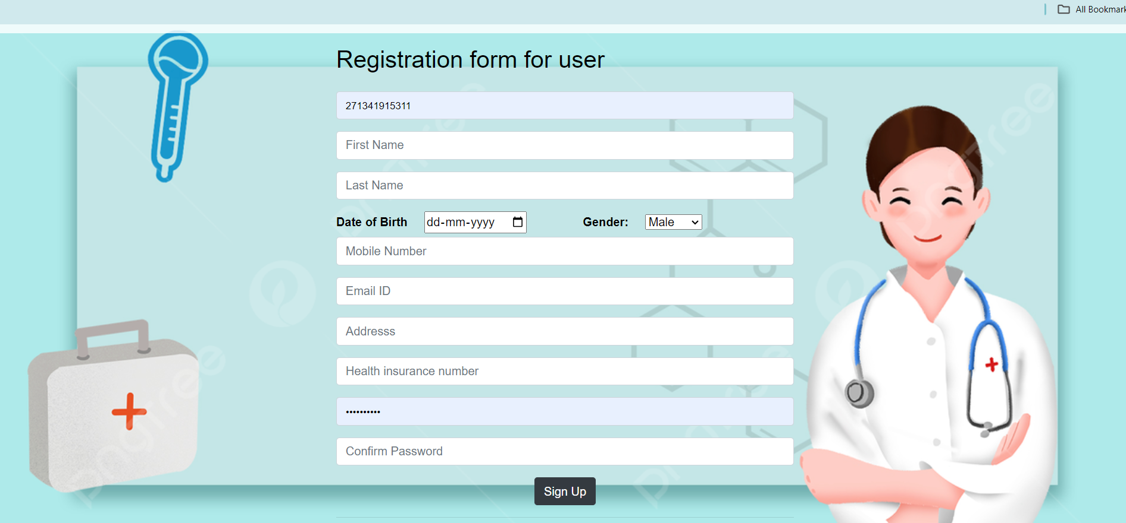

2) login page : If you already have an account then click on login and put the credentials having adhar card number and password

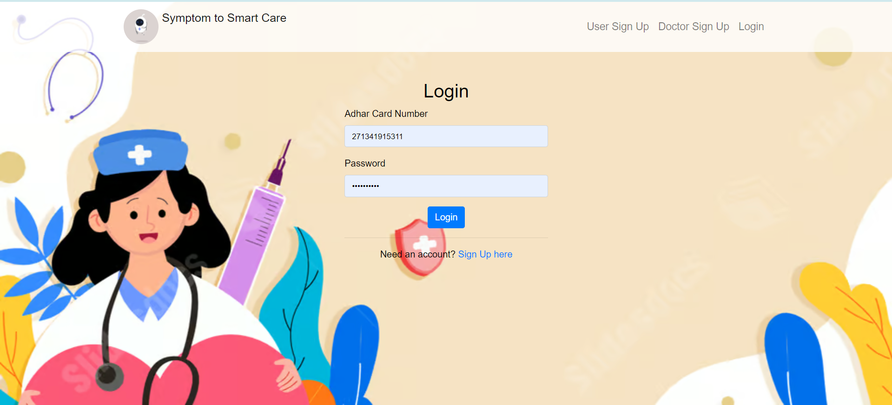

3) Your Profile module : This module will display the profile information of user in tabular form. 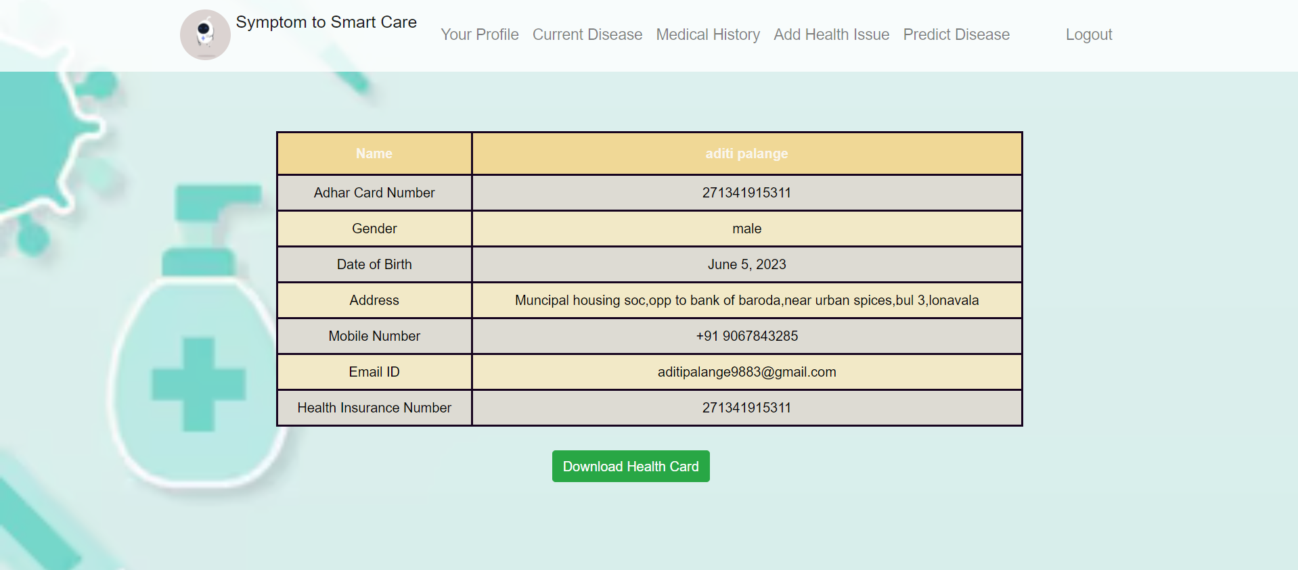

4) Generated heathcard : after clicking on download health card a health card having user information would get downloaded .

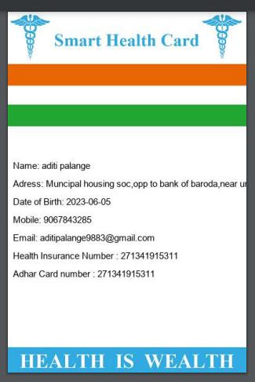

5) Predict Disease: User can predict the disease by giving 5 symptoms out of which atleast 3 are mandatory to predict the disease .



6) Prediction Result : The predicted result screen displays the symptoms given along with the predicted disease and also the percentage of having this disease.

Adittionally it also suggest the specialized doctors treating the disease and medicines required to cure the disease along with the personalized diet plan and exercises.

